**RISK ASSESMENT**

RISK ASSESSMENT IS DONE TO MAKE SURE HIGHLY RISKY ELEMENTS ARE TESTED FIRST.

Open the requirement and click on the Risk assessment module

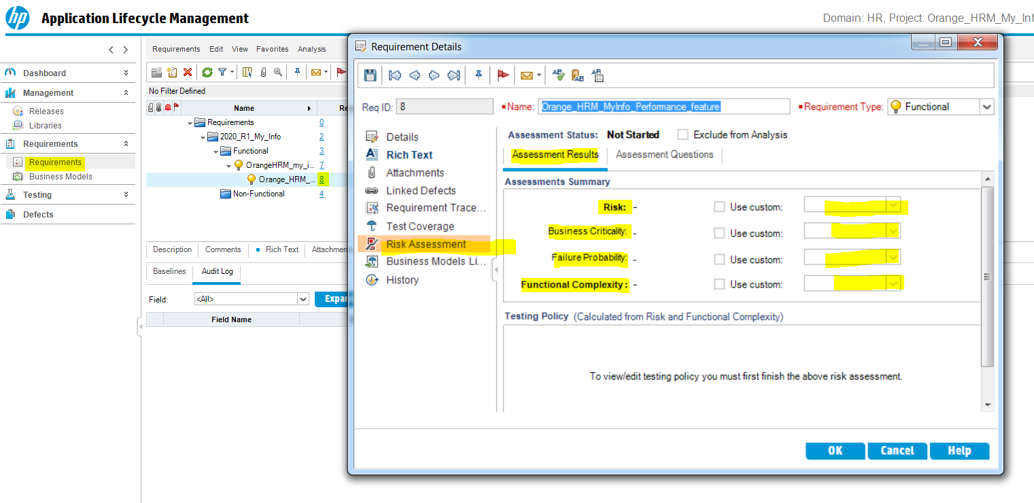

You can either click on the use custom and select answers High, Medium, Low

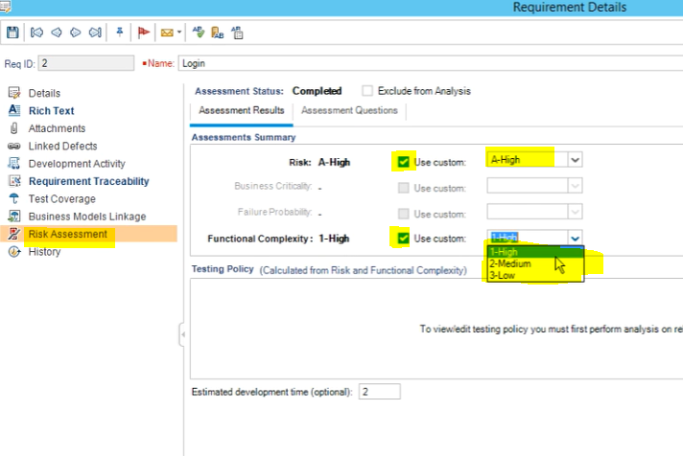

Or you can use answer assessment questions and ALM generates the answers for you.

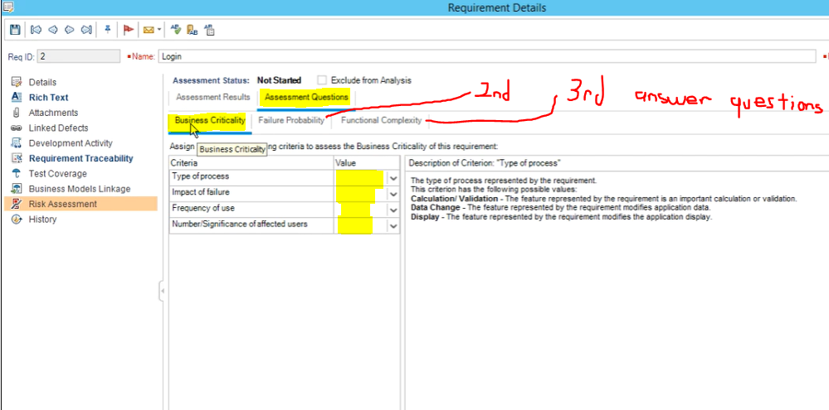

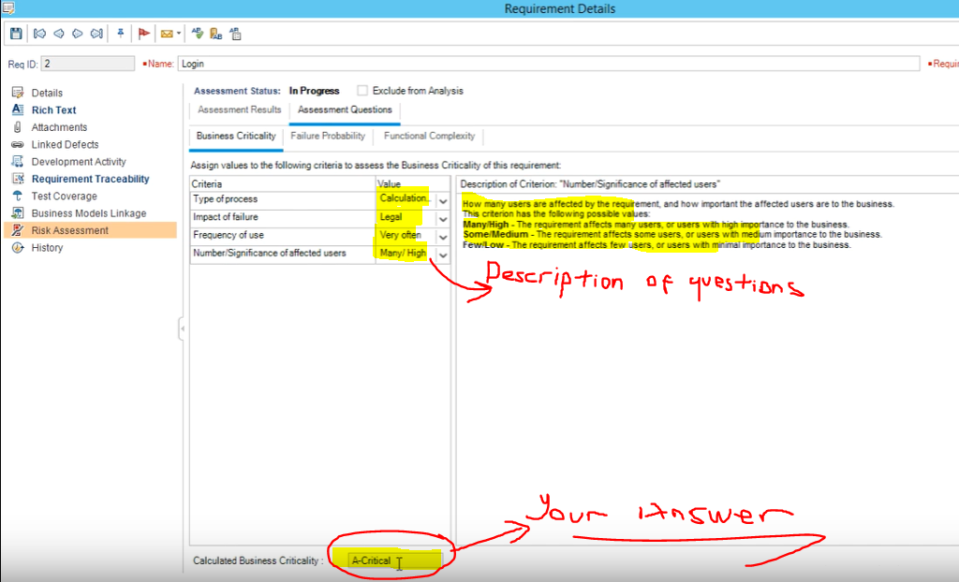

If you go back to Assessment Results you will see your answer A-Critical will be reflected there for you.

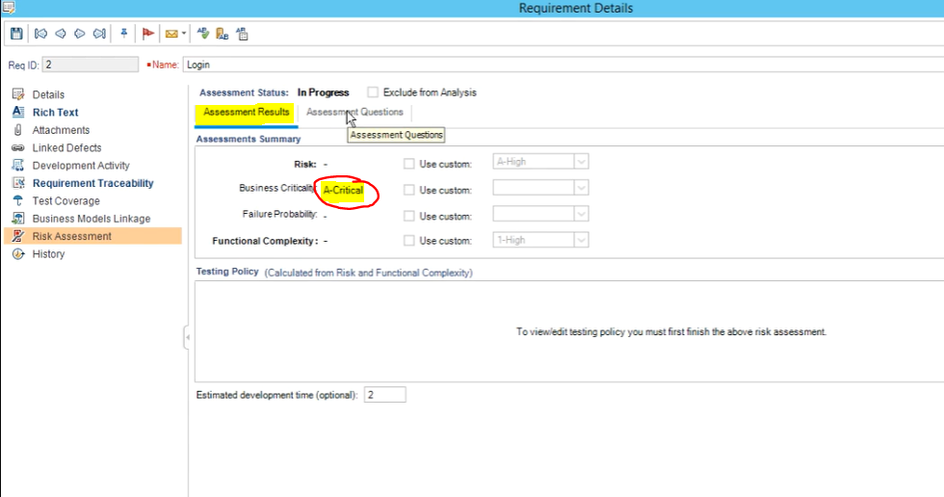

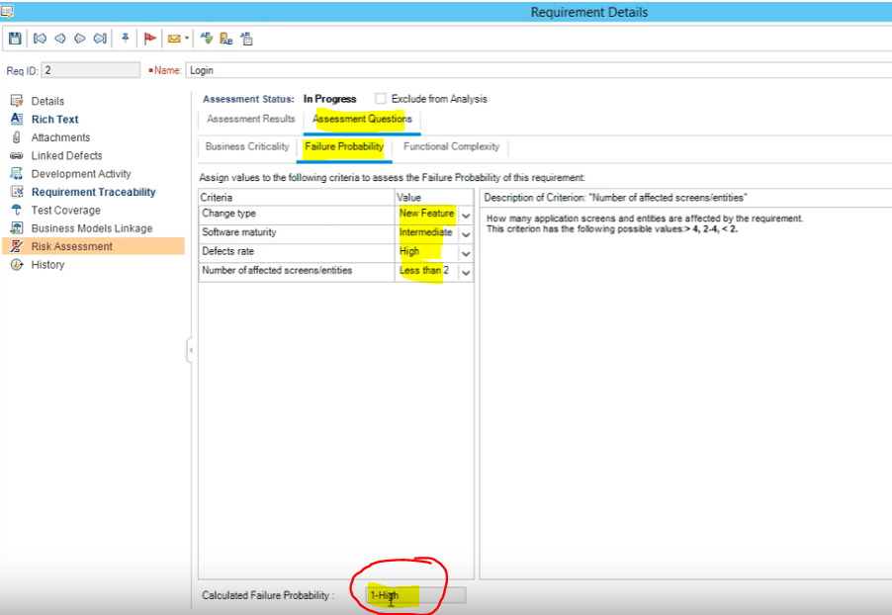

Once you complete all three sections click on Assessment Results

Your final risk will be reflected there

